Problems in Hill Climbing Search

Hill climbing, a widely-used optimization algorithm found in various academic disciplines, is not without its share of challenges that can limit its effectiveness under specific circumstances.

Local Maxima:
Hill climbing often gets trapped in local maxima, which are solutions that seem better than nearby options but may not be the best globally. This issue is especially challenging in complex, multi-dimensional search spaces where superior solutions may be far away.
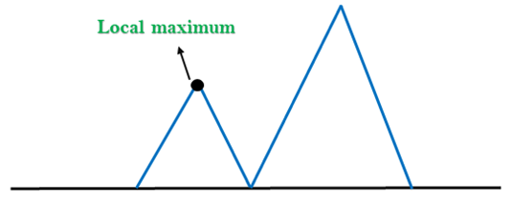
Steepest Ascent vs. First-Choice Hill Climbing:
Steepest ascent consistently chooses the neighbour with the best improvement, reducing the risk of local optima but requiring more computational resources. In contrast, first-choice hill climbing randomly selects a better neighbour, making it easier to escape local optima but potentially slowing down convergence and exploration efficiency.

Plateaus and Ridges:
Plateaus and ridges represent regions within the search space where the objective function remains nearly constant over a range of solutions. Hill climbing faces challenges in such areas, as it struggles to differentiate between solutions of similar quality. It often makes minor, ineffective adjustments, delaying substantial progress toward the global optimum, resulting in protracted and less efficient searches.
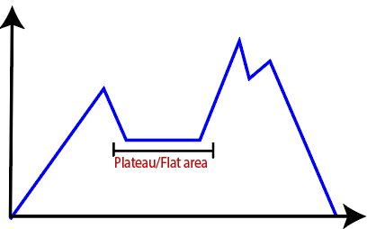
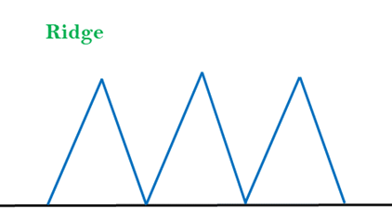

Limited Exploration:
Hill climbing's step-by-step approach can limit exploration by prioritising current solution improvement, potentially neglecting distant, better solutions. Achieving the right balance between exploration and exploitation is challenging, with some variants introducing randomness or perturbation to encourage exploration.

